IRISH
DENTAL JOBS
I R E L A N D S O N L Y D E N T A L R E C R U I T M E N T A G E N C Y

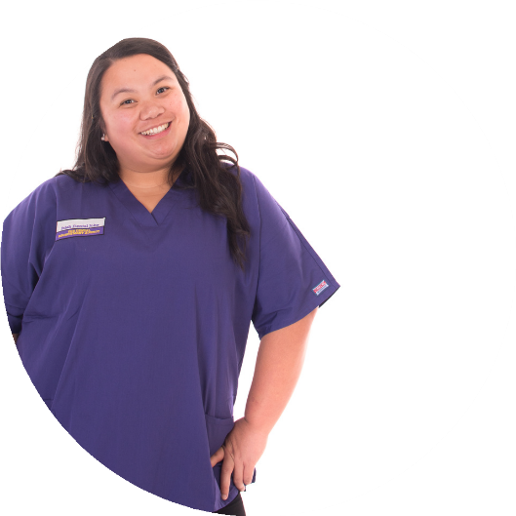
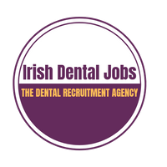
EXECUTIVE SUMMARY
I am a dental nurse who specializes in _. I have gathered 15
years experience working in _.

MY EXPERTISE
Fast-moving Ortho Reception Management
Experience in ____

HOW TO CONTACT ME
Address: 123 Anywhere St., Any City, County Louth
Phone: (123) 456-7890
Email: hello@reallygreatsite.com
Website: www.reallygreatsite.com

PERSONAL
REFERENCES
Anne BangCFO, Hewres-Belte Corp. (123) 456-7890
hello@reallygreatsite.com
Chy WatersCOO, Velveral Foods Inc. (123) 456-7890
hello@reallygreatsite.com

RELEVANT EXPERIENCE

Dental Nurse
Dublin Dental Practice | July 2020 - present
-
-
-
-

Dental Nurse/Reception
Louth Dental Clinic | April 2017 - June 2020
-
-
-
-
-

EDUCATION

Trinity College
Professional Certificate Fall 2016
-
-
-

Brayershire College
BA Sales and Commerce Graduated June 2016
-
-
-

